The Old Town of Beit Jala: A Historic and Architectural Gem
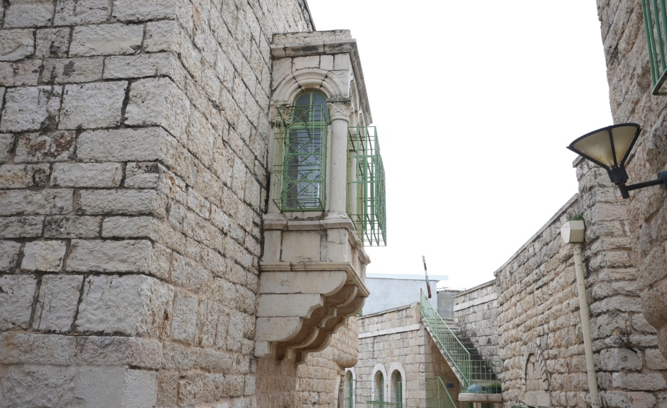
The Old Town of Beit Jala is one of Palestine's prominent historical landmarks. It is characterized by its narrow alleys and stone buildings, which reflect a rich history spanning centuries. Located just two kilometers from Bethlehem, Beit Jala offers a living example of the region's architectural beauty and cultural heritage.

Neighborhoods and Quarters
The Old Town consists of five main quarters, each with its own distinctive character and history:
- Al-Kanis Quarter: Considered one of the oldest quarters, it is home to numerous historic buildings and churches.
- Al-Sama'neh Quarter: Known for its winding alleys and closely built houses, reflecting the city's traditional character.
- Al-Iraq Quarter: Distinguished by its elevated location and panoramic views of the surrounding areas.
- Al-Deir Quarter: Home to several monasteries and important religious sites.
- Al-Sarar Quarter: Known for its distinctive architectural style and spacious courtyards.
Together, these five quarters form a unique architectural fabric that reflects the long-standing history and traditions of Beit Jala.

Notable Landmarks in the Old Town
The Old Town contains a number of historic and religious sites that attract visitors and those interested in the city's rich heritage:
- Saint Nicholas Church: One of the oldest churches in the city, distinguished by its unique architectural design and spiritual significance to the local community.
- The Church of the Annunciation: One of Beit Jala's prominent religious landmarks, known for its distinctive architectural design.
- Housh Musleh: A historic residential complex that reflects the city's traditional architectural style and offers a glimpse into the social life of earlier generations.
- Historic Olive Presses: The Old Town is home to three historic olive presses, two of which are located in Al-Kanis Quarter. They were traditionally used to produce the olive oil for which the area was renowned.

Architecture and Design
The buildings of Beit Jala's Old Town are characterized primarily by Ottoman-era architectural influences, along with some remains dating back to the Byzantine period. Houses are built from locally sourced limestone and feature vaulted ceilings and arched windows.
The narrow alleys and winding passageways reflect an urban layout shaped, in part, by the need for protection and security during earlier historical periods.

Social and Cultural Life
The Old Town was once a center of social and cultural activity in Beit Jala. It was home to traditional markets and public squares where residents gathered for trade and social interaction. Religious celebrations and social occasions were also held throughout the Old Town, reflecting the strong sense of community and social cohesion among its residents.
The Old Town of Beit Jala remains a living testament to the city's rich history and distinctive architectural heritage. Through its narrow alleys and five historic quarters, visitors can experience the atmosphere of the past and appreciate the beauty of traditional architecture that tells the stories of generations gone by.

